# The First Draft Of My Thesis

|  |
| --- |
| **Summary by myself:** |
| **The main topic:** in this thesis is action recognition technical, so to talk it well and to tell some one how you study it form zero. |
| This thesis aims to apply for a patent, since I want to create something new and it is maybe used in our lives in the near future. |
| Only focus on the accelerometer and Gyroscope of Iphone |

# Table of contents

## Declaration

## Table of Figures

Picture 2.2.1 Working principle of a capacitive accelerometer(Andrea Nisticò)

Picture 2.2.2 Accelerometer Theory & Design

Picture 2.2.3 and 2.2.4 Using a Three-Axis Accelerometer and GPS Module in a Smart Phone to Measure Walking Steps and Distance(Ying-Wen Bai, Chia-Hao Yu and Siao-Cian Wu

## Table of Tables

## Glossary of Abbreviations

## Acknowledgements

## Abstract

# Introduction

## Background Information

(introduce why I want to use gyroscope and accelerometer to create something here, to read some materials and summarize my own words.)

Nowadays, the rapid development of science and technology has brought lots of conveniences to human daily life and one kind of technologies, action recognition technique, starts to permeate every corner of our lives. Maybe you still haven’t noticed it yet, but exactly you have high possibility of using it before. There are some examples of the applications in our daily lives of this technique: health smart watch that help us to recording the steps every day we walk; robots that can simulate some actions of human; racing game that you just need to move your hands to play games. Absolutely, action recognitions technique is not also just those,

## Acknowledgements

# Accelerometer with steps algorithm

## The introduction and working principle of an accelerometer

### What is an accelerometer

Wikipedia explains : “An accelerometer is a device that measures proper acceleration. Proper acceleration, being the acceleration of a body in its own instantaneous rest frame, is not the same as coordinate acceleration, being the acceleration in a fixed coordinate system”. Exactly, an accelerometer is not hard to understand and you just need to know it is used to test the physical acceleration, which is taught in high school physics course and is the rate of change of velocity of an object.

（reference: Accelerometer Theory & Design）

The accelerometer can be divided into piezoelectric, piezoresistive and capacitive types according to working principle. Different types suit different circumstances, but those techniques are exactly doing the same thing converting a mechanical motion into an electrical signal. Here, we do not need to discuss too deep for the different inner structures of those types, since it does not affect we use it.

### Working principle of an accelerometer

As I mentioned before that an accelerometer is used to test the acceleration of an object. What is the acceleration here? Actually it is the change rate of the velocity of an object, and can be described as the ‘a’ in formula: F=-kx=ma, we studied in middle or high school courses.

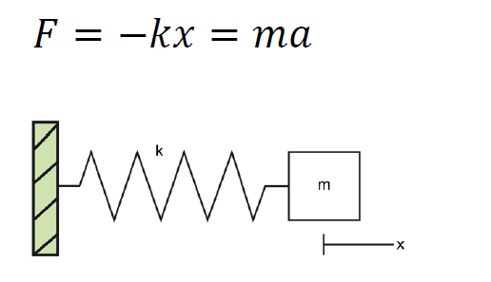

(Picture 2.1.2.1 Working principle of a capacitive accelerometer(Andrea Nisticò))

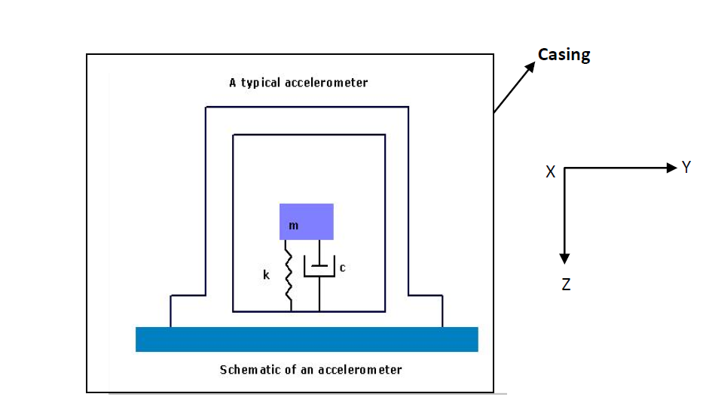

(Picture 2.1.2.2 Accelerometer Theory & Design)

As the picture2.2.2 above shows the schematic of an accelerometer, which be comprised of a mass (m), a spring (k) and a dashpot. When the object moves and has an accelerations, the mass moves to another position, the spring (k) will stretches and the dashpot will produce an relative damping coefficient(c) and the value (c) can be transfer to a digital signal or number which can be used directly.

The exact inner structure of an accelerometer is just like this, absolutely not, in our daily life, the most popular type of accelerometers is the Three-Axis Acceleration Sensor such as iPhone installing it. Just as its name implies, the three-axis accelerometer does not only test one direction’s acceleration, but three directions’ accelerations: X, Y and Z.

### How an accelerometer works in mobile phone.

Here, we just use the three-axis accelerometer of an iPhone as an example to describe how an accelerometer works in an iPhone.

As we mentioned before, a three -axis accelerometer is used to test three different directions’ acceleration. There are two pictures below, which show three dimensional axis and the acceleration of every axis can be tested by the accelerometer installed in the phone.

And maybe some beginners will ask how to get the three axes data from an iPhone. Exactly, there are lots of app creating the function to catch the efficient data directly from the phone. Introducing one free iPhone APP named “Physics Toolbox Sensor Suite”, which can get not only the data of accelerometer from the iPhone to email to your email box, but also Gyroscope which will be discuss in next chapter and Magnetometer sensor. The data of accelerometer and gyroscope from an iPhone in this thesis is almost caught by this APP.

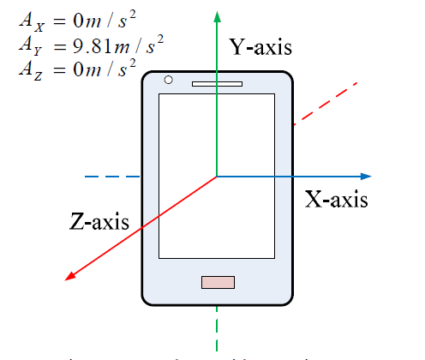 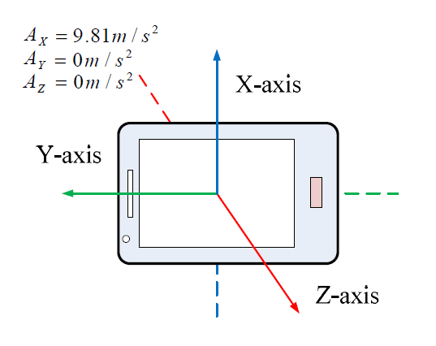

(Picture 2.1.3.1 and 2 Using a Three-Axis Accelerometer and GPS Module in a Smart Phone to Measure Walking Steps and Distance(Ying-Wen Bai, Chia-Hao Yu and Siao-Cian Wu))

## The principle of testing steps

### How an accelerometer works in human body

When a pedestrian is walking on the road, the accelerometer will divide the motion acceleration by three directions, as we can see in the picture 2.2.1.1 below: Vertical Direction, Forward Direction and Side Direction, which can be also called: X, Y and Z Axis.

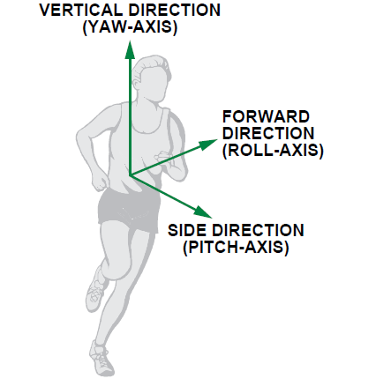

(Picture 2.2.1.1 Full-Featured Pedometer Design Realized with 3-Axis Digital Accelerometer)

### The features of one steps

There is a swing phase showed in picture 2.2.2.1,which is a step period during people movement. Absolutely, there is a change process of speed of the leg movement during one step period, so we can catch the acceleration using the accelerometer.

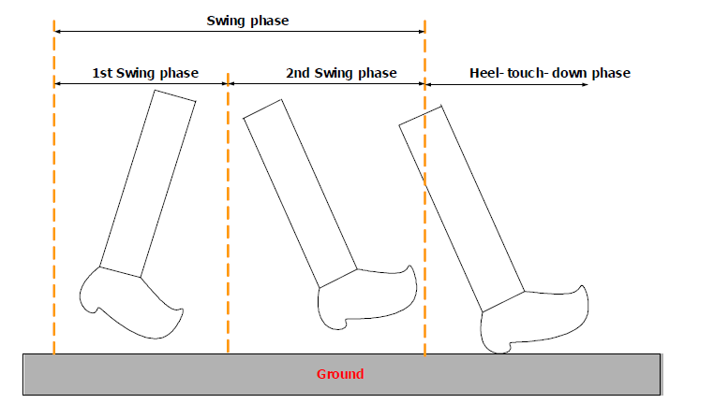

(Picture 2.2.2.1 A Step, Stride and Heading Determination for the Pedestrian Navigation System)

Picture 2.2.2.2 below shows the typical three axes, x, y and z (matching vertical, forward and side acceleration) data of the accelerometer in my iPhone during walking, and what conclusion can be judged from this picture. So no matter how the pedometer wears the phone, there is at least one axis data have sharply periodic changes (this picture shows the Y axis changing sharply).

Picture 2.2.2.2

Normally, we can calculate a peak value and a bottom value during one step.

And we can use the sum formula to get a diagram below picture 2.2.2.3. As a valid step must have only one peak value and one bottom value.

Picture 2.2.2.3

## Key algorithms of recording steps

### Peak Detection Algorithm

Four Basic Conditions can be used: (the frequency of thedata caught in this chapter is in 50Hz)

|  |
| --- |
| 1.Current point is going down.(The Red Point in the following diagram)  2. The previous point is going up.(The Black Point) |
| 3. At least going up twice before coming to positive peak.(The pink lines). |
| 4. The value of the positive peak should be bigger than 1.5g |

And we can go on to understand this algorithm by referring to the following diagram.

### Transform Domain Algorithm

One condition can be used to exclude invalid data.

1. The duration of two effective adjacent peaks must be longer than 0.2S and shorter than 2s. (Based on common sense)

So we can see the two red peak values are invalid using this algorithm.

### Threshold Filtering Algorithm

Two Basic Conditions:

|  |
| --- |
| 1. The current peak value minus the last valley value must be bigger than the threshold. |
| 2. The Threshold is Dynamic and related with different walking patterns. (There is one red peak datum being filtered.) |

The following diagram can be an example for this algorithm.

### Pattern Recognition Algorithm

One regulation is:

|  |
| --- |
| For examples:(the walking patterns)   1. Walking, phone in pocket. 2. Walking, phone in hands. 3. Walking, phone beside ear. 4. Running, phone in pocket.   1. In different patterns, you can see the distinction of the wave variation of accel value from the picture on the right. The following diagram shows the difference between the pattern of walking with the phone in the pocket and the pattern of running with the phone in the pocket. |

## My pedometer program

### The program operation

To run this program showed in follow picture, you can get the exact steps and the accuracy of steps calculation. How to use this program to calculate the steps, there are two procedures below should be done :

1. Fill out the path of excel file of Accelerometer data and the test frequency before click Running.
2. Fill in the exact count steps in the Exact Steps, and click Calculating.

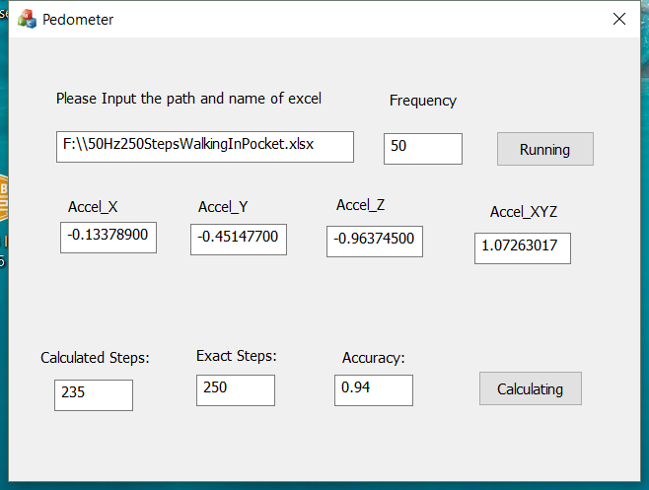

### The accuracy of results

We can get the accuracy of this program and this algorithm showed in following form. Of course, there is not the most accurate program or algorithm, and the purpose is to show the method for calculating steps.

|  |  |  |  |  |  |  |  |  |  |  |  |  |  |  |  |  |  |  |  |  |  |  |  |  |  |  |  |  |  |  |  |  |  |  |  |  |  |  |  |  |  |  |  |  |  |  |  |  |  |  |  |  |  |  |  |  |  |  |  |  |
| --- | --- | --- | --- | --- | --- | --- | --- | --- | --- | --- | --- | --- | --- | --- | --- | --- | --- | --- | --- | --- | --- | --- | --- | --- | --- | --- | --- | --- | --- | --- | --- | --- | --- | --- | --- | --- | --- | --- | --- | --- | --- | --- | --- | --- | --- | --- | --- | --- | --- | --- | --- | --- | --- | --- | --- | --- | --- | --- | --- | --- |
| |  |  |  |  |  |  |  |  |  |  | | --- | --- | --- | --- | --- | --- | --- | --- | --- | --- | | **Action pattern** | **Placement of Iphone** | **Height** | **Weight** | **Age** | **ground condition** | **Frequncy** | **Number of step (exactly)** | **number of steps(by program)** | **Accuracy** | | **Walking** | in pocket of pants | 173cm | 60 Kilo | 28 | Flat | 25Hz | 150 | 250 | 0.6 | | **Walking** | in pocket of pants | 173cm | 60 Kilo | 28 | Flat | 50Hz | 235 | 250 | 0.94 | | **walking** | in hand(Natural Vertical) | 173cm | 60 Kilo | 28 | Flat | 50Hz | 243 | 258 | 0.94 | | **Walking** | Put the Phone Beside Ear (to answer the phone call) | 173cm | 60 Kilo | 28 | Flat | 50Hz | 192 | 250 | 0.77 | | **Running** | In pocket of Pants | 173cm | 60 Kilo | 28 | Flat | 50Hz | 258 | 250 | 0.97 | |

# Gyroscope with balance racing game

## The introduction of Gyroscope

### What is a gyroscope

Wikipedia explains : “gyroscope is a device used for measuring or maintaining [orientation](https://en.wikipedia.org/wiki/Orientation_(geometry)) and [angular velocity](https://en.wikipedia.org/wiki/Angular_velocity).”

It is a spinning wheel or disc in which the axis of rotation is free to assume any orientation by itself. When rotating, the orientation of this axis is unaffected by tilting or rotation of the mounting, according to the [conservation of angular momentum](https://en.wikipedia.org/wiki/Conservation_of_angular_momentum).

### Working principle of a gyroscope

### How a gyroscope works in iPhone

## The difference between a gyroscope and an accelerometer

## The racing game with Gyroscope

# Glow Stick with Accelerometer and Gyroscope